**NAME: ADEDIRE EMMANUEL KOLAWOLE**

**MATRIC NO: 140591003**

**COURSE CODE: CSC 428**

**INTERACTIVE COMPUTER GRAPHICS**

Interactive computer graphics is a computer graphics system that allows the operator or user to interact with the graphical information presented on the display using one or more of a number of input devices, some of which are aimed at delivering positions relevant to the information being displayed. Almost all computer workstations and personal computer systems are now able to be used interactively. Examples of interactive graphics are;

* Cathode ray tube
* Liquid crystal display
* L.E.D
* Plasma

We will consider Liquid crystal display as an example.

**LIQUID CRYSTAL DISPLAY**

LCD (liquid crystal display) is the technology used for displays in notebook and other smaller computers. LCDs allow displays to be much thinner than cathode ray tube technology. LCDs consume much less power than LED and gas-display displays because they work on the principle of blocking light rather than emitting it. An LCD is made with either a passive matrix or an active matrix display display grid. The active matrix LCD is also known as a thin film display. The passive matrix LCD has a grid of conductors with pixels located at each intersection in the grid. A current is sent across two conductors on the grid to control the light for any pixel. An active matrix has a transistor located at each pixel intersection, requiring less current to control the luminance of a pixel. For this reason, the current in an active matrix display can be switched on and off more frequently, improving the screen refresh time (your mouse will appear to move more smoothly across the screen, for example).

**Facts That Should Be Considered While Making an LCD:**

1. The basic structure of LCD should be controlled by changing the applied current.
2. We must use a polarized light.
3. Liquid crystal should able be to control both of the operation to transmit or can also able to change the polarized light.

**Organization or Structure of L.C.D**

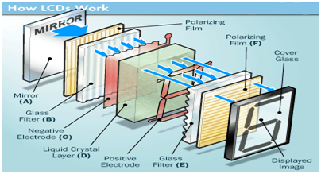

As mentioned above that we need to take two polarized glass pieces filter in the making of the liquid crystal. The glass which does not have a polarized film on the surface of it must be rubbed with a special polymer which will create microscopic grooves on the surface of the polarized glass filter. The grooves must be in the same direction of the polarized film. Now we have to add a coating of pneumatic liquid phase crystal on one of the polarized filter of the polarized glass. The microscopic channel cause the first layer molecule to align with filter orientation. When the right angle appears at the first layer piece, we should add a second piece of glass with the polarized film. The first filter will be naturally polarized as the light strikes it at the starting stage.

Thus the light travels through each layer and guided on the next with the help of molecule. The molecule tends to change its plane of vibration of the light in order to match their angle.  When the light reaches to the far end of the liquid crystal substance, it vibrates at the same angle as that of the final layer of the molecule vibrates. The light is allowed to enter into the device only if the second layer of the polarized glass matches with the final layer of the molecule.